- What is CSS? Describe Different types of CSS with example

CSS (Cascading Style Sheets) is a stylesheet language used to describe the presentation of a web page written in HTML or XML. CSS controls the layout, colors, fonts, spacing, and responsiveness of a webpage, making it visually appealing and user-friendly.

Types of CSS
There are three main types of CSS:
1. Inline CSS
Inline CSS is applied directly within an HTML element using the style attribute. It affects only the specific element where it is applied.
Example:
<!DOCTYPE html>
<html>
<head>
<title>Inline CSS Example</title>
</head>
<body>
<h1 style="color: blue; font-size: 24px;">This is a heading with inline CSS</h1>
</body>
</html>
Advantages:
- Quick and easy to apply for a single element.
- Does not require an external stylesheet.
Disadvantages:
- Hard to maintain for large projects.
- Overrides external and internal styles, leading to difficulty in debugging.

2. Internal (Embedded) CSS
Internal CSS is written inside a <style> tag within the <head> section of an HTML document. It applies styles to all elements within the same HTML file.
Example:
<!DOCTYPE html>
<html>
<head>
<title>Internal CSS Example</title>
<style>
body {
background-color: lightgray;
}
h1 {
color: green;
text-align: center;
}
</style>
</head>
<body>
<h1>This is a heading with internal CSS</h1>
</body>
</html>

Advantages:
- No need for an external CSS file.
- Allows styling multiple elements in the same HTML file.
Disadvantages:
- Increases HTML file size.
- Cannot be reused across multiple pages.

External CSS
- Stored in a separate .css file and linked to an HTML document using the <link> tag.
- Best practice for large projects because it improves maintainability and keeps HTML clean.
Example:
Html File :
<!DOCTYPE html>
<html>
<head>
<title>External CSS Example</title>
<link rel="stylesheet" type="text/css" href="styles.css">
</head>
<body>
<h1>This is an external CSS example</h1>
</body>
</html>
External CSS:
h1 {
color: red;
font-size: 30px;
text-align: center;
}

- What is a selector in CSS? Discuss the different types of selectors in CSS with suitable examples

A CSS selector is a pattern used to select and style specific elements in an HTML document. Selectors define which elements the CSS rules apply to.

Types of CSS Selectors
CSS provides various types of selectors to target elements in different ways. The main types are:
- Universal Selector (*)
- Element Selector
- Class Selector (.)
- ID Selector (#)
- Group Selector (A, B, C)
- Attribute Selector ([attribute])
- Pseudo-class Selector (:hover, :nth-child(), etc.)
- Pseudo-element Selector (::before, ::after)
- Combinator Selectors (>, +, ~, )

1. Universal Selector (*)
The universal selector applies styles to all elements in the document.
Example:
* {
margin: 0;
padding: 0;
box-sizing: border-box;
}
This removes the default margin and padding from all elements.
2. Element Selector
Targets all elements of a specific type (e.g., p, h1, div).
Example:
p {
color: blue;
font-size: 18px;
}
This applies styles to all <p> elements.
3. Class Selector (.)
Selects elements that have a specific class. Multiple elements can share the same class.
Example:
.text-red {
color: red;
font-weight: bold;
}
HTML:
<p class="text-red">This text is red.</p>
<span class="text-red">This span is also red.</span>

4. ID Selector (#)
Targets a single element with a unique id.
Example:
#header {
background-color: black;
color: white;
text-align: center;
}
HTML:
<h1 id="header">Welcome to My Website</h1>

5. Group Selector (A, B, C)
Applies the same styles to multiple elements.
Example:
h1, h2, p {
font-family: Arial, sans-serif;
}
This applies the same font style to <h1>, <h2>, and <p> elements.

6. Attribute Selector ([attribute])
Targets elements based on their attributes.
Example:
input[type="text"] {
border: 2px solid blue;
}
HTML:
<input type="text" placeholder="This input is styled">
<input type="password" placeholder="This is not affected">
This styles only text inputs.

7. Pseudo-class Selector (:)
Targets elements based on their state.
Common Pseudo-classes:
Pseudo-class | Description
:hover | Applies styles when hovering over an element
:focus | Styles an element when it gains focus (e.g., input field)
:nth-child(n) | Selects the nth child of a parent element
Example:
a:hover {
color: green;
text-decoration: underline;
}
This changes the color of links when hovered over.

8. Pseudo-element Selector (::)
Styles a specific part of an element.
Common Pseudo-elements:
Pseudo-element | Description
::before | Inserts content before an element
::after | Inserts content after an element
::first-letter | Styles the first letter of a text block
Example:
p::first-letter {
font-size: 30px;
font-weight: bold;
color: red;
}
This makes the first letter of all <p> elements bigger and red.

9. Combinator Selectors
Used to select elements based on their relationship with other elements.
Types of Combinators:
Selector | Description
descendant ( ) | Selects all nested elements
child (>) | Selects direct children only
adjacent sibling (+) | Selects the first sibling that comes immediately after another element
general sibling (~) | Selects all siblings that come after a specified element
Example:
div > p {
color: purple;
}
This selects only <p> elements that are direct children of a <div>.

- Explain CSS box model in detail
The CSS Box Model is a fundamental concept in web design that describes how elements are structured and spaced on a webpage. Every HTML element is treated as a rectangular box, and the box model defines the properties that affect the size, spacing, and positioning of these elements.

Components of the CSS Box Model
Each element’s box consists of four layers, arranged from the inside out:
- Content – The actual text or image inside the element.
- Padding – The space between the content and the border.
- Border – The outline that surrounds the padding and content.
- Margin – The space outside the border that separates elements.

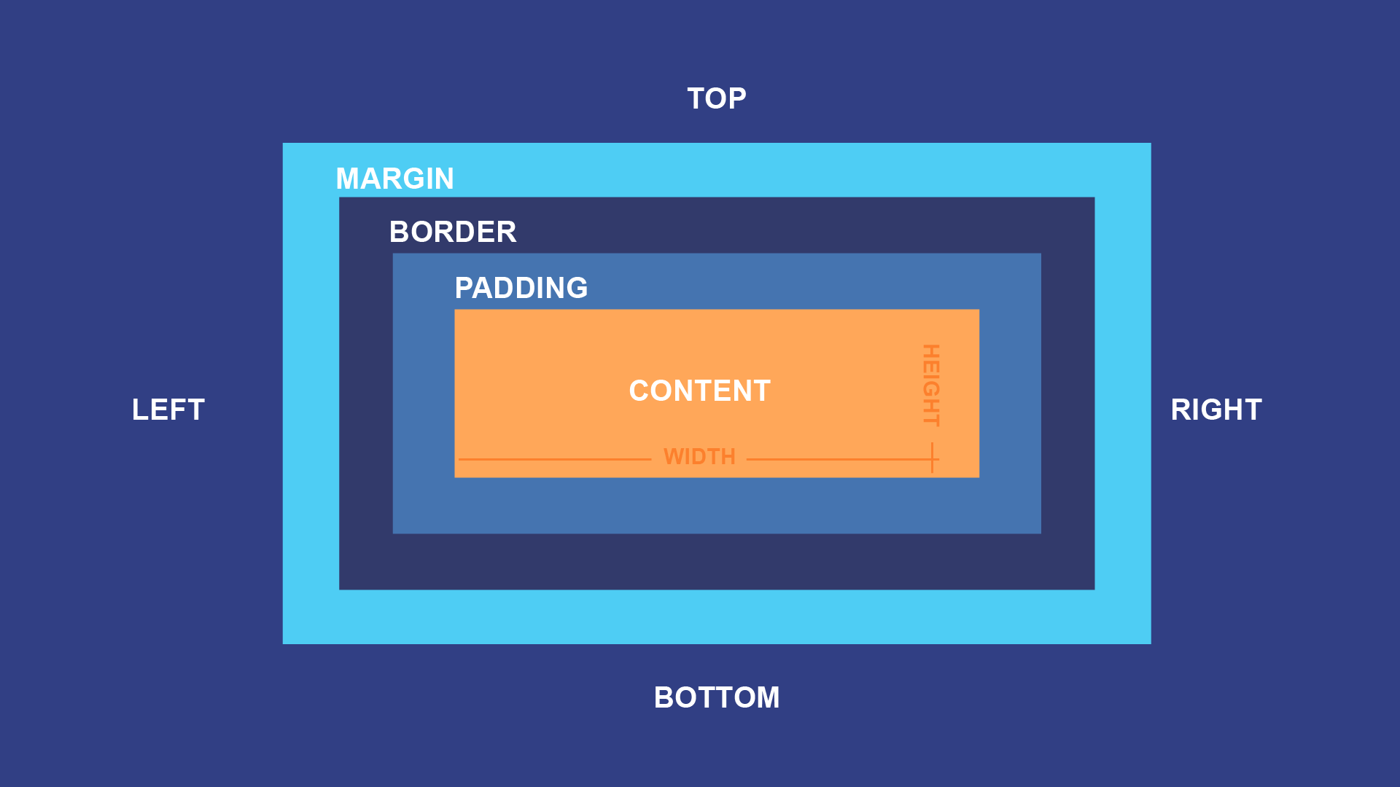

Q4.
<!DOCTYPE html>
<html lang="en">
<head>
<meta charset="UTF-8">
<meta name="viewport" content="width=device-width, initial-scale=1.0">
<title>Grid Layout </title>
<style>
.container {
width: 400px;
height: 300px;
border: 1px solid black;
display: flex;
flex-wrap: wrap;
}

.grid-item {
border: 1px solid black;
box-sizing: border-box;
display: flex;
justify-content: center;
align-items: center;
}

.grid-item.larger-left {
width: 75%;
height: 50%;
}

.grid-item.smaller-right {
width: 25%;
height: 50%;
}
</style>
</head>
<body>

<div class="container">
<div class="grid-item larger-left"></div>
<div class="grid-item smaller-right"></div>
<div class="grid-item larger-left"></div>
<div class="grid-item smaller-right"></div>
</div>

</body>
</html>

Q5.

<!DOCTYPE html>
<html lang="en">
<head>
<meta charset="UTF-8">
<meta name="viewport" content="width=device-width, initial-scale=1.0">
<title>Simple Div Grid Layout</title>
<style>
.container {
width: 600px;
border: 1px solid black;
}

.row {
display: flex;
border-bottom: 1px solid black;
}

.row:last-child {
border-bottom: none;
}

.col {
border-right: 1px solid black;
height: 100px;
}

.col:last-child {
border-right: none;
}

/* Fixed widths instead of flex */
.row-1 .col:first-child { width: 400px; }
.row-1 .col:last-child { width: 200px; }

.row-2 .col:first-child { width: 200px; }
.row-2 .col:last-child { width: 400px; }

.row-3 .col:nth-child(1) { width: 150px; }
.row-3 .col:nth-child(2) { width: 225px; }
.row-3 .col:nth-child(3) { width: 225px; }
</style>
</head>
<body>

<div class="container">
<div class="row row-1">
<div class="col"></div>
<div class="col"></div>
</div>
<div class="row row-2">
<div class="col"></div>
<div class="col"></div>
</div>
<div class="row row-3">
<div class="col"></div>
<div class="col"></div>
<div class="col"></div>
</div>
</div>

</body>
</html>

